

# Recruitment Report

This report provides high-level historical trend numbers for recruiters who are traveling to a prospective area. This **data** is sourced from the **OCAS HIR Person-level Dataset** (Fall 2022).

## Parameters

Municipal area selected: **MILTON**

Intake Term: **FALL**

College Statistics for: **CONESTOGA**

## College Stats: CONESTOGA

### Schools

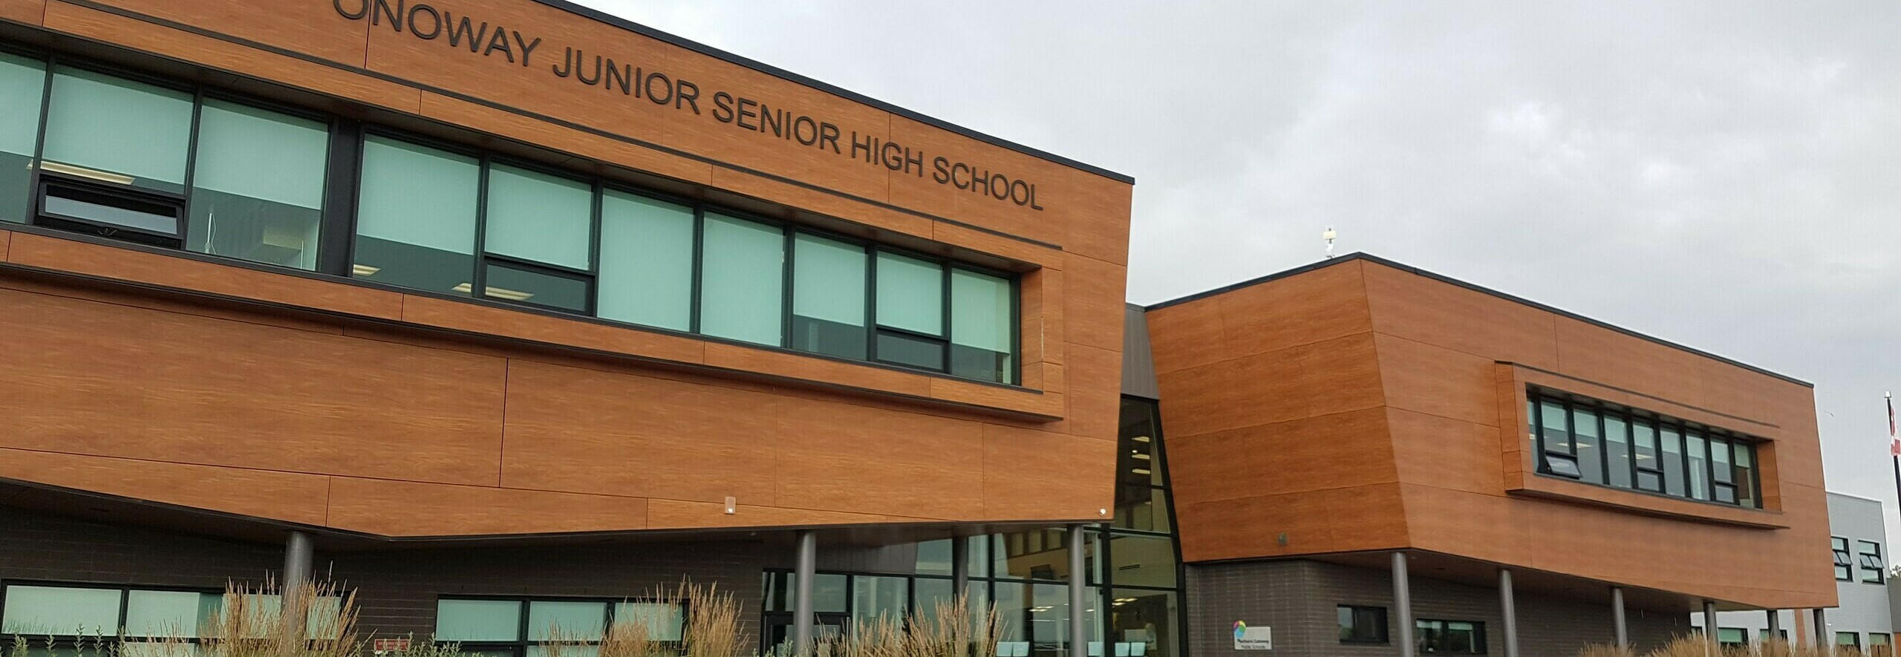

* Over the past five years, there were **5** high schools (or MIDENT student source entities) in this area that had CONESTOGA-related OCAS activity.

| **MIDENT** | **School Name** | **Students** |
| --- | --- | --- |
| 689726 | BISHOP PAUL FRANCIS REDING SECONDARY SCHOOL | 12 |
| 926736 | MILTON DISTRICT HIGH SCHOOL | 10 |
| 696392 | ST. FRANCIS XAVIER CATHOLIC SS MILTON - FORMERLY JEAN VANIER | 9 |
| 967740 | CRAIG KIELBURGER SECONDARY SCHOOL | 8 |
| 940976 | GARY ALLAN HIGH SCHOOL - MILTON | 1 |

* Over the past five years, there have been **40** prospective students from these schools making **29** applications (program choices) to **CONESTOGA**.

### Applications - Program choices



#### Trending Totals - Applications to CONESTOGA

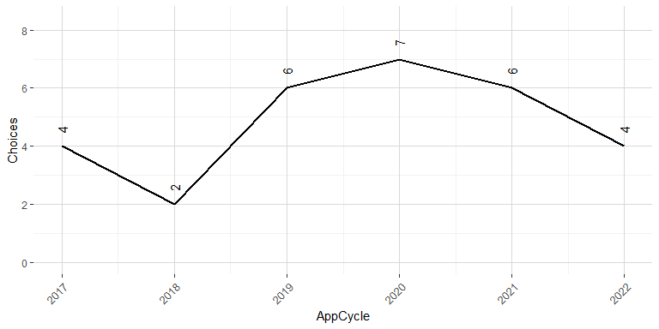

#### Subjects

The top 20 MTCUs being applied to by these students (at CONESTOGA) over the past five years have been the following:

| **MTCU** | **Program** | **Choices** | **%** |
| --- | --- | --- | --- |
| 54701 | GENERAL ARTS AND SCIENCE | 2 | 6.9% |
| 60503 | COMPUTER PROGRAMMER ANALYST | 2 | 6.9% |
| 81400 | BSC NURSING | 2 | 6.9% |
| 83007 | COMMUNITY AND CRIMINAL JUSTICE | 2 | 6.9% |
| 41469 | PERSONAL SUPPORT WORKER | 1 | 3.4% |
| 41598 | PRE-HEALTH SCIENCES PATHWAY TO CERTIFICATES AND DIPLOMAS | 1 | 3.4% |
| 42400 | BOOKKEEPING | 1 | 3.4% |
| 43006 | PRE-SERVICE FIREFIGHTER | 1 | 3.4% |
| 43106 | BAKING - PRE-EMPLOYMENT | 1 | 3.4% |
| 45613 | ELECTRICAL TECHNIQUES | 1 | 3.4% |
| 48200 | CONSTRUCTION TRADES TECHNIQUES | 1 | 3.4% |
| 51024 | ELECTRO MECHANICAL MAINTENANCE | 1 | 3.4% |
| 52006 | JOURNALISM - PRINT AND BROADCASTING | 1 | 3.4% |
| 52316 | OFFICE ADMINISTRATION - EXECUTIVE | 1 | 3.4% |
| 53008 | POLICE FOUNDATIONS | 1 | 3.4% |
| 55610 | POWERLINE TECHNICIAN | 1 | 3.4% |
| 56405 | MOTIVE POWER TECHNICIAN | 1 | 3.4% |
| 61003 | CIVIL ENGINEERING TECHNOLOGY | 1 | 3.4% |
| 62900 | BUSINESS ADMINISTRATION - MARKETING | 1 | 3.4% |
| 68200 | CONSTRUCTION ENGINEERING TECHNOLOGY | 1 | 3.4% |

### Registrations

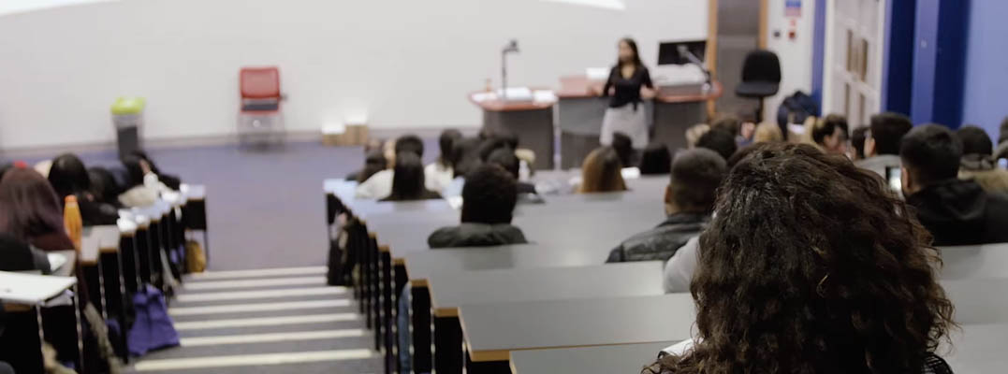

Registrations refer to students who completed the application and confirmation process and became registered students attending classes. Of those those **40** applying students over the past five years, **8** went on to register at **CONESTOGA**.

#### Trending Totals

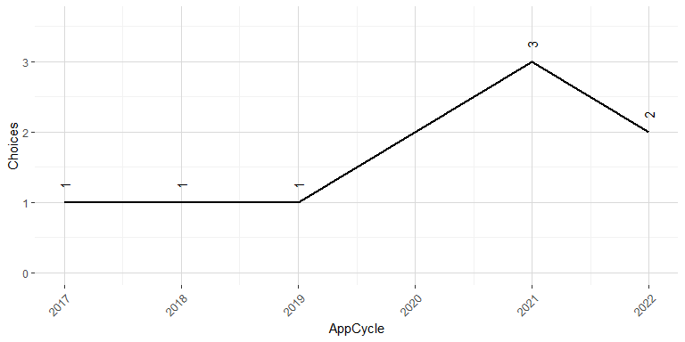

Note: 2022 Registration numbers are incomplete

#### Subjects

The top 20 MTCUs where those students registered (at CONESTOGA) are the following:

| **MTCU** | **Program** | **Registrations** | **%** |
| --- | --- | --- | --- |
| 40719 | HUMAN SERVICES FOUNDATION | 1 | 12.5% |
| 41469 | PERSONAL SUPPORT WORKER | 1 | 12.5% |
| 41599 | PRE-HEALTH SCIENCES PATHWAY TO ADVANCED DIPLOMAS AND DEGREES | 1 | 12.5% |
| 43108 | BARTENDING | 1 | 12.5% |
| 51228 | EDUCATIONAL ASSISTANT | 1 | 12.5% |
| 51637 | PARAMEDIC | 1 | 12.5% |
| 62900 | BUSINESS ADMINISTRATION - MARKETING | 1 | 12.5% |
| 88200 | BACHELOR OF APPLIED TECHNOLOGY (ARCHITECTURE-PROJECT & FACILITY MNGMT) | 1 | 12.5% |

## Summary Stats

### Schools



* Over the past five years, there were **9** high schools (or MIDENT student source entities) with OCAS activity within this area.

| **MIDENT** | **School Name** | **Students** |
| --- | --- | --- |
| 689726 | BISHOP PAUL FRANCIS REDING SECONDARY SCHOOL | 170 |
| 967740 | CRAIG KIELBURGER SECONDARY SCHOOL | 137 |
| 926736 | MILTON DISTRICT HIGH SCHOOL | 130 |
| 696392 | ST. FRANCIS XAVIER CATHOLIC SS MILTON - FORMERLY JEAN VANIER | 114 |
| 940976 | GARY ALLAN HIGH SCHOOL - MILTON | 38 |
| 909190 | ERNEST C DRURY SCHOOL FOR THE DEAF | 10 |
| 907669 | ERNEST C DRURY HIGH SCHOOL - CLOSED | 4 |
| 909203 | E C DRURY/TRILLIUM DEMONSTRATION SCHOOL | 1 |
| 999340 | THOMAS MERTON - INDEPENDENT STUDY | 1 |

* Over the past five years, there have been **605** prospective students from these schools making **454** applications (program choices).

### Applications - Program choices



#### Colleges

The top 20 College destinations for these students have been the following:

| **College** | **Choices** | **%** |
| --- | --- | --- |
| HUMBER | 57 | 12.6% |
| ALGONQUIN | 50 | 11.0% |
| SENECA | 42 | 9.3% |
| SHERIDAN | 37 | 8.1% |
| CENTENNIAL | 34 | 7.5% |
| CONESTOGA | 29 | 6.4% |
| FANSHAWE | 28 | 6.2% |
| GEORGE BROWN | 28 | 6.2% |
| DURHAM | 19 | 4.2% |
| MOHAWK | 19 | 4.2% |
| ST. CLAIR | 18 | 4.0% |
| NIAGARA | 16 | 3.5% |
| GEORGIAN | 12 | 2.6% |
| LOYALIST | 12 | 2.6% |
| CAMBRIAN | 9 | 2.0% |
| FLEMING | 7 | 1.5% |
| LA CITÉ COLLÉGIALE | 7 | 1.5% |
| ST. LAWRENCE | 7 | 1.5% |
| CONFEDERATION | 6 | 1.3% |
| LAMBTON | 6 | 1.3% |

#### Trending Totals

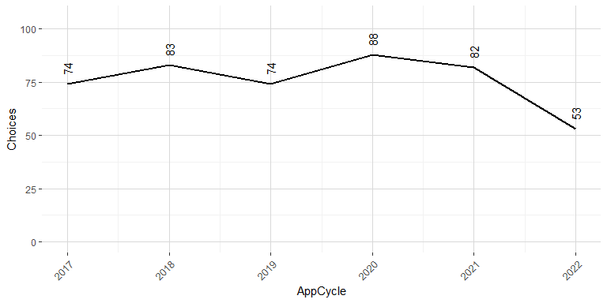

#### Subjects

The top 20 MTCUs being applied to by these students have been the following:

| **MTCU** | **Program** | **Choices** | **%** |
| --- | --- | --- | --- |
| 51407 | PRACTICAL NURSING | 20 | 4.4% |
| 51211 | EARLY CHILDHOOD EDUCATION | 16 | 3.5% |
| 53008 | POLICE FOUNDATIONS | 14 | 3.1% |
| 81400 | BSC NURSING | 13 | 2.9% |
| 50200 | BUSINESS | 11 | 2.4% |
| 50721 | SOCIAL SERVICE WORKER | 11 | 2.4% |
| 41469 | PERSONAL SUPPORT WORKER | 8 | 1.8% |
| 60701 | CHILD AND YOUTH WORKER | 8 | 1.8% |
| 44700 | GENERAL ARTS AND SCIENCE - ONE-YEAR | 7 | 1.5% |
| 51637 | PARAMEDIC | 7 | 1.5% |
| 55613 | ELECTRICAL ENGINEERING TECHNICIAN | 7 | 1.5% |
| 41598 | PRE-HEALTH SCIENCES PATHWAY TO CERTIFICATES AND DIPLOMAS | 6 | 1.3% |
| 41800 | ART FUNDAMENTALS | 6 | 1.3% |
| 43006 | PRE-SERVICE FIREFIGHTER | 6 | 1.3% |
| 44900 | WELDING TECHNIQUES | 6 | 1.3% |
| 50503 | COMPUTER PROGRAMMER | 6 | 1.3% |
| 56405 | MOTIVE POWER TECHNICIAN | 6 | 1.3% |
| 60503 | COMPUTER PROGRAMMER ANALYST | 6 | 1.3% |
| 45613 | ELECTRICAL TECHNIQUES | 5 | 1.1% |
| 52613 | COURT AND TRIBUNAL AGENT | 5 | 1.1% |

### Registrations



Registrations refer to students who completed the application and confirmation process and became registered students attending classes. Of those those **605** applying students, **61** went on to register at a College.

#### Colleges

The top 20 College destinations for these students have been the following:

| **College** | **Registrants** | **%** |
| --- | --- | --- |
| CONESTOGA | 8 | 13.1% |
| FANSHAWE | 8 | 13.1% |
| GEORGE BROWN | 8 | 13.1% |
| SENECA | 8 | 13.1% |
| MOHAWK | 5 | 8.2% |
| ALGONQUIN | 3 | 4.9% |
| CENTENNIAL | 2 | 3.3% |
| DURHAM | 2 | 3.3% |
| FLEMING | 2 | 3.3% |
| LA CITÉ COLLÉGIALE | 2 | 3.3% |
| LAMBTON | 2 | 3.3% |
| LOYALIST | 2 | 3.3% |
| NIAGARA | 2 | 3.3% |
| SHERIDAN | 2 | 3.3% |
| ST. LAWRENCE | 2 | 3.3% |
| GEORGIAN | 1 | 1.6% |
| NORTHERN | 1 | 1.6% |
| ST. CLAIR | 1 | 1.6% |

#### Trending Totals

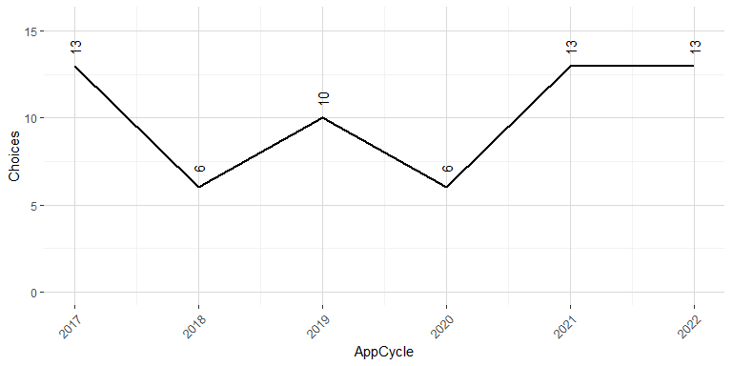

Note: 2022 Registration numbers are incomplete

#### Subjects

The top 20 MTCUs where those students registered are the following:

| **MTCU** | **Program** | **Registrations** | **%** |
| --- | --- | --- | --- |
| 50721 | SOCIAL SERVICE WORKER | 3 | 4.9% |
| 51211 | EARLY CHILDHOOD EDUCATION | 3 | 4.9% |
| 40719 | HUMAN SERVICES FOUNDATION | 2 | 3.3% |
| 41469 | PERSONAL SUPPORT WORKER | 2 | 3.3% |
| 41800 | ART FUNDAMENTALS | 2 | 3.3% |
| 52316 | OFFICE ADMINISTRATION - EXECUTIVE | 2 | 3.3% |
| 53008 | POLICE FOUNDATIONS | 2 | 3.3% |
| 55613 | ELECTRICAL ENGINEERING TECHNICIAN | 2 | 3.3% |
| 60503 | COMPUTER PROGRAMMER ANALYST | 2 | 3.3% |
| 40231 | SMALL BUSINESS | 1 | 1.6% |
| 41211 | DAY CARE ASSISTANT | 1 | 1.6% |
| 41598 | PRE-HEALTH SCIENCES PATHWAY TO CERTIFICATES AND DIPLOMAS | 1 | 1.6% |
| 41599 | PRE-HEALTH SCIENCES PATHWAY TO ADVANCED DIPLOMAS AND DEGREES | 1 | 1.6% |
| 41601 | PREPARATORY HEALTH SCIENCES | 1 | 1.6% |
| 41603 | ANIMAL CARE | 1 | 1.6% |
| 42320 | DENTAL OFFICE ADMINISTRATION | 1 | 1.6% |
| 43108 | BARTENDING | 1 | 1.6% |
| 44700 | GENERAL ARTS AND SCIENCE - ONE-YEAR | 1 | 1.6% |
| 45613 | ELECTRICAL TECHNIQUES | 1 | 1.6% |
| 48200 | CONSTRUCTION TRADES TECHNIQUES | 1 | 1.6% |